[](http://www.google.com/url?sa=i&rct=j&q=&esrc=s&source=images&cd=&cad=rja&uact=8&ved=0ahUKEwiA4-eFyt7TAhWKxYMKHVC1BSEQjRwIBw&url=http://www.clipartkid.com/clip-art-english-grammar-cliparts/&psig=AFQjCNEqfmGmoStimtcjRZ5X5oypuWS64w&ust=1494273851013421)[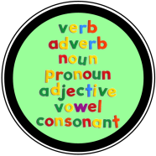](http://www.clipartpanda.com/categories/grammar-20clipart)SP 1 – FINAL EXAM

THE PRESENT TENSE

How are regular verbs conjugated in the present tense?

|  |  |  |  |
| --- | --- | --- | --- |
|  | -ar | -er | -ir |
| **Subject pronouns** | TRABAJAR | COMER | VIVIR |
| yo | trabajo |  |  |
| tú |  |  |  |
| él, ella, usted |  |  |  |
| nosotros/nosotras |  |  |  |
| vosotros/vosotras |  |  |  |
| ellos/ellas/ustedes |  |  |  |

How are irregular yo (YO-Go) verbs conjugated? (KEEP IN MIND THAT SOME OF THESE ARE ALSO BOOT VERBS)

|  |  |  |  |  |
| --- | --- | --- | --- | --- |
|  | -er | -er | -ir | -ir |
| **Subject pronouns** | PONER | TENER | DECIR | SALIR |
| yo |  |  |  |  |
| tú |  |  |  |  |
| él, ella, usted |  |  |  |  |
| nosotros/nosotras |  |  |  |  |
| vosotros/vosotras |  |  |  |  |
| ellos/ellas/ustedes |  |  |  |  |

How are stem-changing verbs conjugated?

|  |  |  |  |  |
| --- | --- | --- | --- | --- |
| **Subject pronouns** | e ie | e i | o ue | u ue |
|  | PENSAR | SERVIR | DORMIR | JUGAR |
| yo | piens**o** |  |  |  |
| tú |  |  |  |  |
| él, ella, usted |  |  |  |  |
| nosotros/nosotras |  |  |  |  |
| vosotros/vosotras |  |  |  |  |
| [Simple Brown Boot Clip Art](http://www.clker.com/cliparts/R/n/T/o/G/0/simple-brown-boot-md.png)ellos/ellas/ustedes |  |  |  |  |

**Write other examples of stem changing verbs:**

e-ie e-i o-ue

THE PRESENT PROGRESSIVE

* -is used to talk about an action that is currently taking place RIGHT NOW!
* This is equivalent to the use of “ing” in English.

The present progressive has TWO components to it. *** Don’t forget step 1!!! ***

1. **A conjugated form of the verb *“estar”.***

____________________ ____________________

____________________ ____________________

____________________ ____________________

1. The present participle. Take off the ending and add the new “ING” participle.

“ar” verbs _______________ Yo estoy habl**ando** con Marta.

“er/ir” verbs _______________ Ella está beb**iendo** limonada.

**¡Ten cuidado! There are Irregular verbs in the present progressive.**

leer ___________________ traer ___________________

oír ___________________ creer ___________________

AFFIRMATIVE TÚ COMMANDS

**“Positive** **Tú** **Commands”/ “Affirmative Tú” Commands” are used in Spanish to tell 1 person, that you know well, to do something.**

* **The formation of the “Tú command” is the same as the ___________________ form of the verb in the present tense.**
* **Write the affirmative tú command below.**

hablar ____________ comer ____________ vivir ____________

**There are irregular affirmative (+) commands. Write the 8 irregular affirmative commands to demonstrate you knowledge.**

poner ____________ tener ____________ venir ____________

salir ____________ ir ____________ decir ____________

hacer ____________ ser ____________

[](http://www.google.com/url?sa=i&rct=j&q=&esrc=s&source=images&cd=&cad=rja&uact=8&ved=0ahUKEwii-o63vt7TAhXFz4MKHQTeBJQQjRwIBw&url=http://24indianews.com/role-model-vin-diesel/&psig=AFQjCNF_vShiQC49COY5HGze3bgCxkrDmg&ust=1494270725959889)

To remember these, we use the mnemonic_______________________________________________

[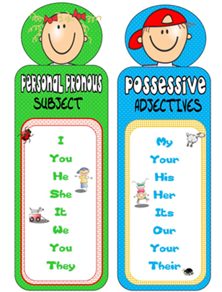](http://www.google.com/url?sa=i&rct=j&q=&esrc=s&source=images&cd=&cad=rja&uact=8&ved=0ahUKEwiZiIryyN7TAhVj74MKHaMqDFgQjRwIBw&url=http://mrskarine.weebly.com/possessive-adjectives.html&psig=AFQjCNFRrCXuxh3rFjUJx9o2dvJT4ZvUPA&ust=1494273523830461)POSSESSIVE ADJECTIVES:

* show who an object belongs to.
* must match number and gender when possible.

- Goes before the noun

mi__ _________

_________ _________

_________ _________

nuestro _________ _________ _________ _________

vuestro _________ _________ _________ _________

*Vuestro is YOURS when referring to the VOSOTROS form “you all” in SPAIN

**Traduce al español:**

My pants are big and ugly. ___________________________________________

Your friend(f) is pretty. ___________________________________________

Their shoes and shirt are expensive. ___________________________________________

[](http://www.google.com/url?sa=i&rct=j&q=&esrc=s&source=images&cd=&cad=rja&uact=8&ved=0ahUKEwiH-8TKyN7TAhUs4oMKHWf-CVsQjRwIBw&url=http://symbolsnet.com/symbols/more-less-than-symbols.html&psig=AFQjCNGZuAxPvwLs6uoBEucscLTseht-Mw&ust=1494273463794050)

COMPARISONS/SUPERLATIVES:

Are used to compare the **inequality** of people/things.

To say that one item/person is superior then the other, use the following pattern.

**más** + **adjective** + **que** Jessica Alba es **más bonita que** Betty White.

To say that one item/person is inferior to the other, use the following pattern.

**menos** + **adjective** + **que** Jennifer Aniston es **menos popular que** Betty White.

To state that an activity is done more or less then another, use the following pattern.

**mayor que** (older than)

**mejor que** (better than)

**menor que** (younger than)

**peor que**  (worse than)

**más que** Yo como **más que** Elisa.

**menos que** El chico estudia **menos que** Roxana.

To say that someone/something is “better” or “worse”, use the following:

**mejor que** LeBron James juega al basquetbol **mejor que** Austin Powers.

**peor que** LeBron James juega al fútbol americano **peor que** Walter Payton.

To single out someone/something as the –est of something, use the following:

**el/la/los/las + (noun) + más + adj** Yo soy **la** chica **más** inteligente de mi clase.

**menos + adj** I am **the** **smartest** girl in the class.

To single out something as “the best” or “the worst” of something, use the following:

Papa John’s es **la peor** pizza. Papa John’s is **the worst** pizza.

Los Cubs son **los mejores** jugadores del país. The Cubs are **the best** players.

IR

* The verb ir is irregular and does not follow the rules for regular verb conjugations.
* You can use *ir + a* to talk about places you are going *to*. Remember that you will need to use the contraction *a + el = al* whenever the place you are going to is masculine.
* You use *ir+ a+ inf* to talk about what you are going to do.

|  |  |  |  |
| --- | --- | --- | --- |
| **IR = to go** | | | |
| yo |  | nosotros |  |
| tú |  | vosotros |  |
| él |  | ellos |  |

Traduce al español.

1. She is not going to the gym today._________________________________________
2. Is he going to cook tomorrow? ____________________________________________

[](https://www.google.com/url?sa=i&rct=j&q=&esrc=s&source=images&cd=&cad=rja&uact=8&ved=0ahUKEwi_6Nya0N7TAhUj6oMKHR5dCTsQjRwIBw&url=https://clipartfest.com/categories/view/12ee9740a05b75a7e2c684862d927a076f703adf/to-be-or-not-to-be-clipart.html&psig=AFQjCNG_BekHmARwy4lzWHv7F6JnUjZ7_g&ust=1494275509389160)¿SER o ESTAR?

|  |  |  |  |  |  |  |  |  |
| --- | --- | --- | --- | --- | --- | --- | --- | --- |
| SER | | | |  | ESTAR | | | |
| yo |  | nosotros |  |  | yo |  | nosotros |  |
| tú |  | vosotros |  |  | tú |  | vosotros |  |
| él |  | ellos |  |  | él |  | ellos |  |

In general:

|  |  |
| --- | --- |
| Ser is used | example |
| to give time of the day or year, the  month, the date, and the day |  |
| to describe physical or personality traits |  |
| to indicate profession |  |
| to indicate origin and nationality |  |
| to indicate relationship |  |

|  |  |
| --- | --- |
| Estar is used | example |
| to tell where someone or something is located at a given moment  (prepositions) |  |
| is used to talk about the feelings / conditions |  |
| is used to form the present  progressive |  |

**La Rima de las Preposiciones**

Izquierda, derecha,

Delante, detrás,   
Encima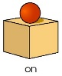, debajo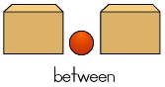,y algo más.   
Aquí, allí, al lado , arriba,

Y ahora, muchachos, cantamos la rima.

Fill in the blanks with conjugations of *ser* or *estar.*

1. Yo _________ muy cansada hoy.
2. Hoy _________ lunes, y _________ las diez de la mañana.
3. ¿Cómo _________ tú? ¿Bien o mal?
4. ¿De dónde _________ Uds.?
5. Luis y Sara _________ estudiantes en OEHS.
6. Mis libros__________encima la mesa.

GUSTAR

* Verbs like *gustar* and *encanta*r do not conjugate like your regular -ar verbs.
* We do not use subject pronouns with these as the subjects are the **things** that are **pleasing** to me, you, him, etc.
* We use indirect object pronouns before the verb to explain WHO is affected by the verb.
* To clarify or emphasize WHO something is PLEASING to, add the following pronouns.

**(a mí, a ti, a él, a ella, a Ud., a nosotros, a vosotros, a ellos, a ellas, a Uds.)**

|  |  |
| --- | --- |
| **GUSTAR = to like, to be pleasing** | |
| presente | pretérito |
| me gusta/gustan | me gustó/gustaron |
| te ___________ | te ___________ |
| le ___________ | le ___________ |
| nos ___________ | nos ___________ |
| os ___________ | os ___________ |
| les ___________ | les ___________ |

**Traduce al español.**

1. I LIKE to ride a skateboard in the park.

______________________________________________________________________________

2. You (fam.) LOVE to read in the classroom.

______________________________________________________________________________

3. She LIKES to sing in the choir at church.

______________________________________________________________________________

4. We LOVE to spend time with friends at the mall.

______________________________________________________________________________

5. They LIKED the food that they ate.

_______________________________________________________________________________

Palabras Interrogativas

* Every question in Spanish has an accent mark when used as a question.
* Some agree in gender and number with the noun (s) that follows them.
* If your answer will have *a,* you should use ¿adónde? in your question.
* If your answer will have *de,* you should use ¿de dónde? in your question.

|  |  |  |  |  |  |
| --- | --- | --- | --- | --- | --- |
| **Palabras Interrogativas** | | | | | |
| **¿Quién? ¿Quiénes?** | Who? | **¿Qué?** | What? | **¿Dónde?** | Where? |
| **¿Con quién?** | With whom? | **¿Cuál?** | Which? | **¿Adónde?** | To where? |
| **¿Cómo?** | How? | **¿Cuándo?** | When? | **¿De dónde?** | From where? |
| **¿Cuántos? ¿Cuántas?** | How many? | **¿Cuánto? ¿Cuánta?** | How much? | **¿Por qué?** | Why? |

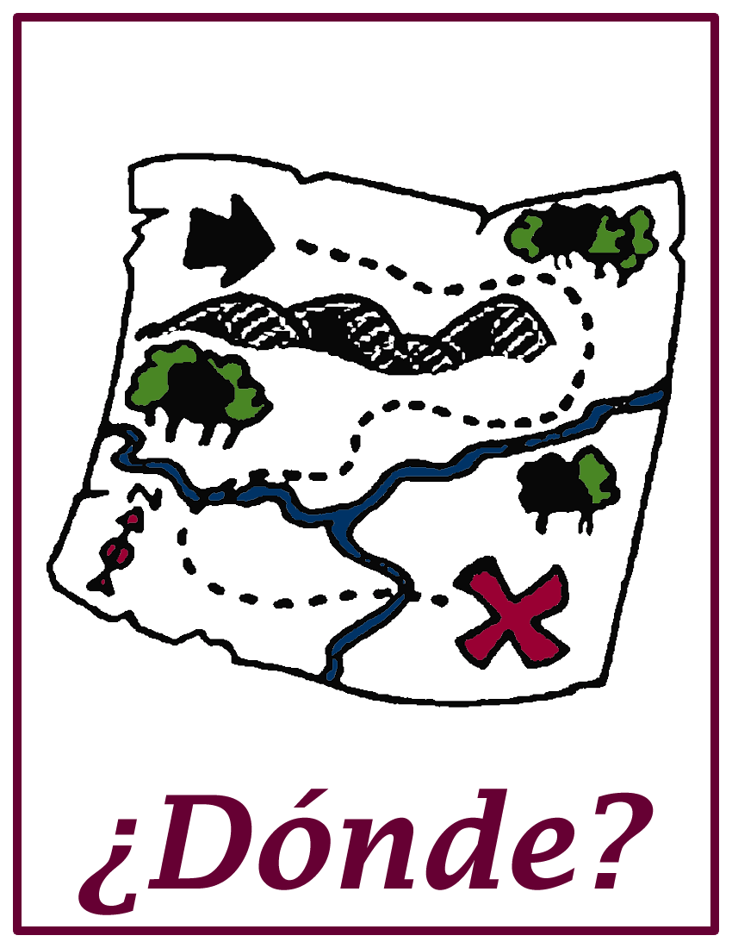

Llena el espacio con la palabra interrogativa correcta.

1. ¿ ___________________ vas hoy después del cine?

--Yo voy a casa después del cine.



2. ¿ ___________________ vas a la playa?

--Voy a la piscina en el verano cuando hace sol.

3. ¿ ___________________ está tu mamá?

--Mi mamá está bien, gracias.

4. ¿ ___________________ está el gimnasio?

--El gimnasio está en Yorkville.

5. ¿ ___________________ es tu profesora de español?

--Mi profesora de español es la señora Suárez.

6. ¿ ___________________ es tu familia?

--Mi familia es de México.

[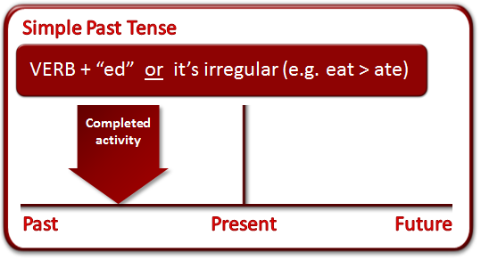](http://www.google.com/url?sa=i&rct=j&q=&esrc=s&source=images&cd=&cad=rja&uact=8&ved=0ahUKEwjx0s3jzd7TAhUh7oMKHeOWCsQQjRwIBw&url=http://www.grammar-monster.com/glossary/past_tense.htm&psig=AFQjCNGP7TUpWqviekIquIuqnd-5aR7mig&ust=1494274857124288)PRETERIT TENSE

What are the endings in the Preterite tense?

* Conjugate in the Preterite.

|  |  |  |  |
| --- | --- | --- | --- |
|  | -ar | -er | -ir |
| yo | hablé | comí | viví |
| tú |  |  |  |
| él, ella, usted |  |  |  |
| nosotros/nosotras |  |  |  |
| vosotros/vosotras |  |  |  |
| ellos/ellas/ustedes |  |  |  |

* **Verbs that end in: -car, -gar, and -zar have spelling changes in the “yo” form to maintain the original sound of the verb in its infinitive from.**
* **Fill in the blanks with the correct conjugations.**

|  |  |  |  |
| --- | --- | --- | --- |
|  | c qu | g gu | z c |
|  | **buscar** | **llegar** | **almorzar** |
| yo |  |  |  |
| tú |  |  |  |
| él, ella, usted |  |  |  |
| nosotros/nosotras |  |  |  |
| vosotros/vosotras |  |  |  |
| ellos/ellas/ustedes |  |  |  |

* List other ~CAR, ~GAR, ~ZAR verbs that follow the pattern above.

|  |  |  |  |
| --- | --- | --- | --- |
|  | c qu **_________** | g gu **_________** | z c **_________** |
| yo |  |  |  |
| tú |  |  |  |
| él, ella, usted |  |  |  |
| nosotros/nosotras |  |  |  |
| vosotros/vosotras |  |  |  |
| ellos/ellas/ustedes |  |  |  |